Lab 5 (2nd Session)

Verilog Basics

Continuous Assignment

* In-Lab

Bring previous codes (D-Flipflop) with you.

**Task (Use Vectors for declaring variables)**

* **Write Verilog code for a 4-bit adder using four full adders**

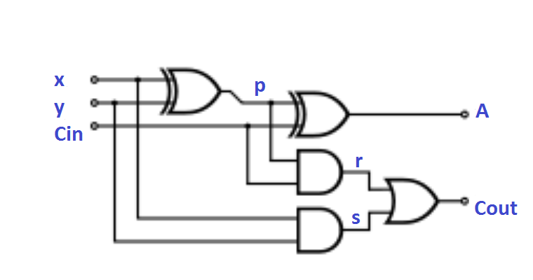

**Full Adder**

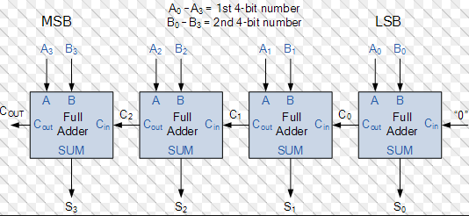

* **Write Verilog HDL description for a 4-bit register with parallel load using D-Flipflops.**

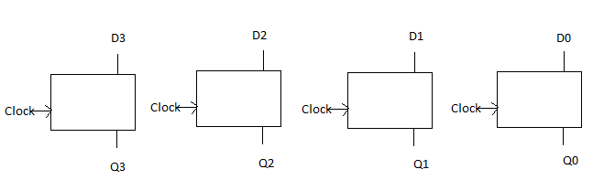

* Post-Lab
* **Write a Verilog HDL description for 4-bit counter using previous two task.**

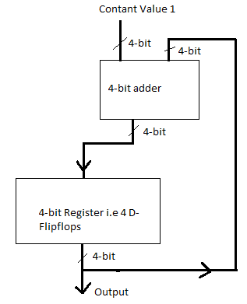

* **Use Univeral Shift Register to create a 4 bit counter.**
* **Your lab report, a .doc file, should contain properly commented Post-Lab task code, with Screenshots(of print preview) of Schematic and waveforms, and Critical Analysis.**
* **The report must have a title page in the pescribed format.**
* **Name the .doc file RegNo.docx; eg SP14-BCE-99.docx**
* **Send it to** [**khiyamiftikhar@gmail.com**](mailto:khiyamiftikhar@gmail.com)**. With subject Lab No.**